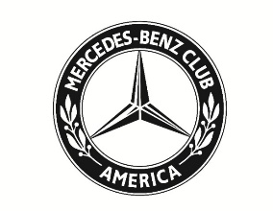
MBCA Western Reserve Section
15th Annual Old Car Fun Day
Saturday, July 29th, 2023
Our 15th annual Old Car Fun Day will be hosted by WRS President Rod Thompson (3175 Roundwood Road, Hunting Valley, Oh 44022) on Saturday, July 29th. The event will start at 11:00 a.m. and end when the last question is answered.
Old Car Fun Day is open to all years and models and provides a forum for owners and enthusiasts to meet each other and chat about their experiences as drivers and owners of older M-Bs. If you have a question or are experiencing a problem with your car, this is a great opportunity to get answers from your fellow enthusiasts.
Those of you who attended Old Car Fun Day last year may recall that there were several presentations about the history of automotive fuels and the effects of the industry switch to EVs. There were a lot of great discussions during the Q&A session that followed.
As a follow up to last year’s event, section member Fred Gwinn will give us an overview of his experiences as an owner of 3 different EVs—Tesla, Porsche, and Mercedes-Benz. Fred will also describe his recent cross-country trip in his EQS450.
Old Car Fun Day continues to focus on members displaying their Mercedes-Benz, getting tips on caring for and enjoying their car, and getting a look at the future. What a fun way to spend a few hours on Saturday!
Registration is $20 per person and includes a luncheon of pulled pork sandwiches, cole slaw, potato salad, Great Lakes Oktoberfest Beer & other refreshments. The deadline is Wednesday July 26th!
Clip and mail the form below with your check payable to MBCA Western Reserve Section to: Rod Thompson (3175 Roundwood Rd. Hunting Valley. OH 44022) or register and pay online at www.benzclub.org
Questions: Contact Rod at renold.thompson@clevelandship.com or (440) 247-2853

Name______________________________________________ Phone ___________________________

Email_________________________________________ # attending ______ X $20 = __________ total

