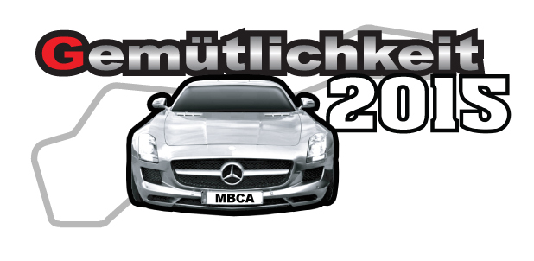
Gemutlichkeit 2015 Driving Event FAQs

1. What is defensive driving?

Defensive driving has 2 components—a classroom session to explain the courses you will drive and also to explain the theory behind the course elements; and in-car driving sessions with a qualified instructor/coach to guide you. The ultimate goal is to help you to become a safer, more confident highway driver. No matter how long you have been driving, defensive driving will help you to sharpen your skills and also can help you to be more comfortable with the safety technology in the newer cars. The course elements are driven at moderate speed and you will have several opportunities to drive each course until you are comfortable with them.

2. What is autocross?

Autocross is the next logical step after defensive driving. You will drive through a course defined by cones that is designed to be driven at low-to-moderate speeds. The goal is to complete the course as quickly as possible without hitting any of the cones. The emphasis is on smoothness, proper use of the eyes, and car control. After several practice runs, there will be timed runs to see how much you’ve improved—and you might even win a trophy! Instructors will be available to help you through the course.

3. What is a high-performance driving school?

A high-performance driving school is held at a road racing course—in this case the new Pittsburgh International Race Course long track—that gives you chance to drive on a real race track and to learn the basics of track driving. There will be plenty of classroom time to learn track basics including course rules and understanding the flag signals. All passing is controlled and there is no door-to-door racing. Behind the wheel, you will have an instructor/coach to help you to learn the best “line” around the track and to help you to improve your skills. The focus is on becoming a more confident and competent track driver while getting more comfortable with the performance capabilities of your Mercedes-Benz. The goal is to make us all safer drivers on the highway.

4. What do I need to do to prepare my car for MBCA driving events?

The preparation varies depending on the events you will be participating in. For all events including defensive driving, you should do the following:

Remove all loose items from the interior and trunk of the car (cell phones, GPS units, athletic gear, umbrellas, jack, spare tire—in short, anything that is not fastened securely should be removed from the car. This will keep loose objects from becoming a distraction.

Remove the driver’s floor mat

Check tire pressures—make sure your tires are at least set at the factory pressures and are not
underinflated. For autocross and track driving, most drivers increase the tire pressures 5-10 psi to reduce tire wear and to improve handling. As tire pressures should be checked when the tires are cold, it is a good idea to adjust tire pressures prior to your arrival at the event.

Take a look under the hood to make sure there are no obvious leaks.

Make sure you have plenty of fuel!

If this sounds like normal vehicle maintenance—you are correct!

5. What do I need to do to prepare for the performance driving school and time trials?

Anyone participating on the track at Gemutlichkeit 2015 must have the MBCA Tech Inspection sheet completed by a competent mechanic. It is not required for defensive driving or autocross. A copy is included in the registration packet The participant is responsible for the condition and safety of their car. Having fresh brake pads and brake fluid are vital! The on-site tech inspection will verify that you have completed the inspection and that the car has no apparent leaks, properly torqued wheel bolts, and have appropriate tire pressures and tire tread.

6. What safety equipment do I need?

Helmets are not required (but can be used) for defensive driving. A Snell 2005 or newer helmet is required for all other driving events. Either motorcycle or automotive helmets are acceptable; bicycle helmets are not. A small number of rental helmets will be available at the track.

Safety belts must be worn at all times. Factory supplied belts are fine; special “racing” harnesses are not required.

Attire: Closed-toe shoes are required for all events (no sandals!). Drivers are required to wear long pants and long-sleeved shirts for all track events. It is suggested that the pants and shirts be a non-synthetic material.

7. I think my Mercedes-Benz is too old or too slow for track events?
I’ve never driven on a track before and I don’t want to embarrass myself?
I don’t want to hurt my car?

These are common questions / concerns among those who have not attended a MBCA national event. In past events, members have driven cars from the 1950s as well as brand-new cars, 4-cylinder diesels, or AMGs. Cars are classed with other similar vehicles so slower cars are not competing with faster cars. Every driver was an inexperienced first-timer so the other participants and driving instructors understand your concerns. The best way to overcome them is to JUST DO IT !! Each driver is encouraged to drive at the speeds that they are comfortable with. Regarding hurting your car, Mercedes-Benz are designed for performance driving so your car will actually “enjoy” the event as much as you will.

8. What types of awards can I win?
Prizes are awarded in each of the classes for autocross and will be presented at the final awards banquet.

