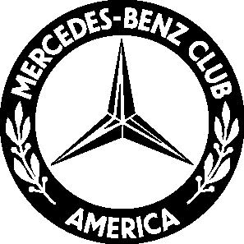

MBCA Western Reserve Section
Concours Judging School
Saturday May 14th

At our concours judging school conducted by MBCA National Concours Chair
Peter Lesler, you can

- take the mystery out of show car judging
- learn the MBCA judging process—it’s easier than you think!
- get “hands-on” judging experience
- get helpful tips on how to prepare your car for concours judging
- become qualified as a MBCA judge

and best of all…

- Use your new-found knowledge to volunteer to judge at MBCA events including
Gemütlichkeit 2011 & StarTrack

Date: Saturday May 14th 10 am-4 pm
Location: Fairfield Inn & Suites 9783 State Route 14 Streetsboro OH 44241
Cost: $10 per person including lunch & materials
Questions: Contact Pete Lesler (330) 562-2841 or email w113sl@aol.com

Register and pay online at www.benzclub.org or mail your registration to:

Pete Lesler
997 Goldenrod Trail
Aurora OH 44202

---------------------------------------------------------------------------------------------------------------------------------------

Please sign me up for the judge’s school on May 14. Enclosed is my check payable to MBCA Western Reserve for $10 per person.

Name______________________________________________ # attending _________

Phone____________________________ email _________________________________

